CE213 Class Problem Sheet 2 (Week 3)

**Assignment Briefing:** [**https://moodle.essex.ac.uk/course/view.php?id=3651**](https://moodle.essex.ac.uk/course/view.php?id=3651)

|  |  |  |
| --- | --- | --- |
| 8 | 7 | 6 |
| 5 | 4 | 3 |
| 2 | 1 |  |

|  |  |  |
| --- | --- | --- |
| 8 | 7 | 6 |
| 5 | 4 | 3 |
| 2 |  | 1 |

|  |  |  |
| --- | --- | --- |
| 8 | 7 | 6 |
| 5 | 4 |  |
| 2 | 1 | 3 |

…… ……

|  |  |  |
| --- | --- | --- |
| 1 | 2 | 3 |
| 4 | 5 | 6 |
| 7 | 8 |  |

(Goal configuration)

How to represent the 8-puzzle problem as state space?

Which node to expand next?

* Which node is closer to the goal configuration? – Need heuristics!

How to expand? – There could be 2, 3, or 4 possible tile moves, depending on the location of the empty square.

(Q1) Which of the following statements is true about depth first search?

[A] It expands the least recently generated node.

[B] It expands the most recently generated node.

[C] It expands the node that has been reached at lowest cost.

[D] It expands the node that is closest to the goal state.

(Q2) The diagram below shows six towns: A, B, C, D, E and F. The numbers alongside the lines indicate the lengths of the roads between the towns.

20

35

40

40

45

30

B

E

D

**A** are asked to find a short route from A to F. Using these rough estimates to evaluate alternative route choices, determine the route you would select if you employed a *hill-climbing* strategy. Calculate the length of this route.A

**F**

C

20

The table below provides rough estimates of the length of the shortest distance from each town to town F.

|  |  |
| --- | --- |
| Town | Distance from F |
| A | 80 |
| B | 60 |
| C | 27 |
| D | 50 |
| E | 30 |
| F | 0 |

You are asked to find a good route from A to F. Using these rough estimates as a heuristic, determine the route you would select if you adopt *A* search*.

(i) List the nodes that would be expanded in the order in which they would be

chosen for expansion.

(ii) State the route that would be found using this method.

(iii) State the length of this route.

State the route that would have been found if you had used:

(iv) Greedy search

(v) Uniform cost search

Has A* search found an optimal solution? Why?

If unform cost search checks whether a generated node is goal state immediately after it is generated and stops search as soon as a goal state is reached, will uniform cost search find optimal solution in this case?

N.B. Based on this question, some multiple choice questions could be designed.

e.g., during the uniform cost search,how many of the 6 nodes will not be selected for expansion?

[A] 0

[B] 1

[C] 2

[D] 3

If ‘during uniform cost search’ is replaced by ‘during A* search’, will the answer be the same?

Topics: Blind search and heuristic search

Answers or hints:

Q1: B (A. BFS; B. DFS; C. Uniform cost search; D. Greedy search)

Q2: Follow the similar search procedures as described in the lecture notes, as illustrated below:

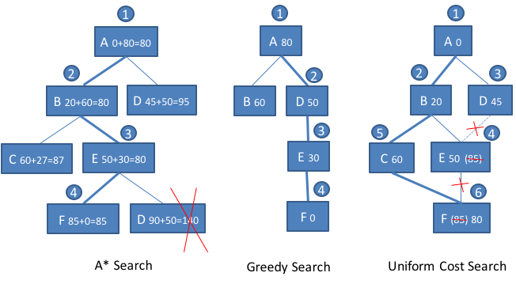

Answers:

1. A, B, E, F
2. A->B->E->F
3. 20+30+35=85
4. A->D->E->F
5. A->B->C->F

A* search has not found an optimal solution to this problem, because the heuristic is not admissible: The estimated shortest distance between C and F is 27 in the table, whilst the actual distance between C and F is 20 only. Therefore, the heuristic overestimates the cost, and thus is not admissible. If we change the estimated distance between C and F to 19, then the heuristic is admissible, and A* search will find the optimal route.

If unform cost search checks whether a generated node is goal state immediately after it is generated and stops search as soon as a goal state is reached, then it will not find optimal solution in this case.

Play the PPT slides on the CE213 Moodle to see the search tree construction procedure by A* search and uniform cost search respectively.

Answers for the multiple choice questions: [A] (if uniform cost search); [C] (if A* search).